附件1：论文摘要模板
Collaborative Robots with Passive Gravity Compensation
Min-Jaekyung¹, Kook-Hyun Ahn² and Jae-Bok Song^{3*}
^{1,2,3}Department of Mechanical Engineering, Korea University, Korea
*E-mail: jbsong@korea.ac.kr,
Conventional industrial robots have remained in shape and function without major changes since their first introduction in 1961. In recent years, however, a novel design of robot arms shown in Fig. 1, called a collaborative robot, has emerged into the market. Several collaborative robots on the market today are featured by human-robot collaboration, safe physical human-robot interaction, easy teaching for non-experts, modular & lightweight design and so on. Most of these robots are limited in size and weight (payload less than 10 kg) because they are working together with workers in the shared space. However, in some cases, human-robot collaboration requires handling a payload higher than 20 kg, but such a large-sized collaborative robots have not been developed for safety reasons [1].
A novel collaborative robot whose weight is about 120 kg and which handles a payload of 25 kg was developed in this study, as shown in Fig. 2. This robot was originally designed for the assembly at the automotive factory where heavy parts such as tires, bumpers, doors and so on are frequently assembled.
Collision safety is the most important issue. The proposed robot is capable of collision prediction & avoidance based on ultrasonic sensors and collision detection & reaction based on the motor current monitoring and friction model of the harmonic drive [2]. A robot should be less expensive for extensive use and energy efficient for reduced operational costs. To this end, a novel counterbalance mechanism based on springs are adopted for this robot. This mechanism can effectively compensate for the gravitational torques required to support the robot mass for any robot configuration. Therefore, low-power actuators are sufficient to achieve high performance, thus significantly improving the safety and reducing the cost related to the actuators. Furthermore, the use of low-power actuators for the same task can significantly reduce the energy driving the actuators, thus leading to a reduction in operating costs. A hand guiding capability based on the 6 axis force/torque sensor and compliance control is also important for a worker and a robot to handle the same object together. This type of robot can be used in the applications in which the robot is in charge for a heavy payload and the worker is responsible for perception and intelligence.
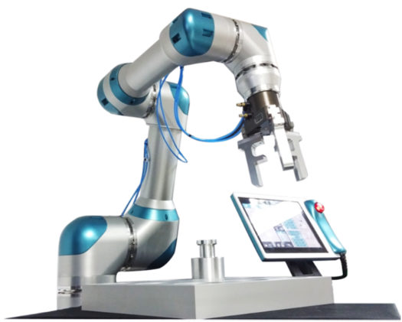  Fig. 1 7-DOF collaborative robot capable of collision detection and direct teaching | 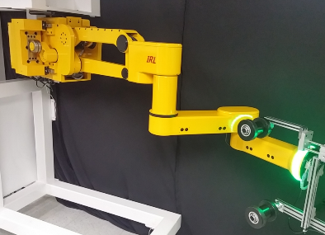  Fig. 2 6-DOF collaborative robot with passive gravity compensation

References
[1] H.-S. Kim, J.-K. Min, J.-B. Song, “Multi-DOF Counterbalance Robot Arm based on Slider-Crank Mechanism and Bevel Gear Units,” IEEE Trans. on Robotics, 32(1), pp. 230-235, 2016.
[2] R. Siciliano, L. Sciavicco, L. Villani, Robotics: Modeling, Planning and Control, Springer.
附件2：2018机械工程新兴技术国际会议参团报名表

中国机械工程学会：
我单位推荐选派 同志参加中国机械工程学会代表团，于今年8月前往韩国参加2018机械工程新兴技术国际会议。所需费用由我单位承担。
负责人签字： 单位公章： 日期：
单位名称 | 中文：
 | 英文：
单位地址 | 中文： |  | 邮编：
 | 英文：
参团人员 | 姓名中文： | 姓名拼音： | 性别：
 | 出生年月日： | 出生地： | 专业：
 | 身份证号码：
护照信息 | 号码： | 签发地：
 | 有效期到： 年 月 日 | 签发时间： 年 月 日
职务/职称 | 中文： | 英文：
联系方式 | 电话： | 传真：
 | 手机： | 电邮：
外语能力 | □能担任口译 □ 一般会话 □能阅读 □基本不会
机舱要求 | □头等舱 □公务舱 □经济舱
住房要求 | □套间 □单人间 □双人间
希望出国交流话题
任务通知书主送单位
联系人 | 姓名： | 电邮：
 | 电话： | 传真：

附件3：2018机械工程新兴技术国际会议初步议程安排

时间 日期 | 2018年8月19日  星期日 | 2018年8月20日  星期一 | 2018年8月21日  星期二 | 2018年8月22日  星期三
08:00~18:30 |  | 注册 | 注册 | 注册
08:30~09:00 |  | 开幕式 | 大会报告 2 | 大会报告 4
09:00~09:30 |  | 大会报告 1
09:30~10:00 |  |  | 茶歇 | 茶歇
10:00~10:30 |  | 茶歇 | 会议及讨论 | 海报展示3
10:30~11:00 |  | 会议及讨论
11:00~11:30
11:30~12:00 |  |  |  | 闭幕式
12:00~12:30 |  | 午餐 | 午餐 | 会后参观
12:30~13:00
13:00~13:30 |  | 主题报告1, 2, 3 | 主题报告4,5,6
13:30~14:00 |  | 休息 | 休息
14:00~14:30 |  | 会议及讨论 | 会议及讨论
14:30~15:00
15:00~15:30
15:30~16:00 |  | 休息 | 休息
16:00~16:30 | 注册 | 会议及讨论 | 海报展示2
16:30~17:00
17:00~17:30 |  |  | 休息
17:30~18:00 |  | 休息 | 大会报告3
18:00~18:30 | 欢迎晚宴 | 海报展示1
18:30~19:00 |  |  | 晚宴
19:00~19:30
19:30~20:00
大会报告：50分钟；主题报告：40分钟；特邀报告人：30分钟；口头报告：15分钟；海报展示讨论：2分钟

