◆ Template for Abstract Submitted
Collaborative Robots with Passive Gravity Compensation
Min-Jaekyung¹, Kook-Hyun Ahn² and Jae-Bok Song^{3*}
^{1,2,3}Department of Mechanical Engineering, Korea University, Korea
*E-mail: jbsong@korea.ac.kr,
Conventional industrial robots have remained in shape and function without major changes since their first introduction in 1961. In recent years, however, a novel design of robot arms shown in Fig. 1, called a collaborative robot, has emerged into the market. Several collaborative robots on the market today are featured by human-robot collaboration, safe physical human-robot interaction, easy teaching for non-experts, modular & lightweight design and so on. Most of these robots are limited in size and weight (payload less than 10 kg) because they are working together with workers in the shared space. However, in some cases, human-robot collaboration requires handling a payload higher than 20 kg, but such a large-sized collaborative robots have not been developed for safety reasons [1].
A novel collaborative robot whose weight is about 120 kg and which handles a payload of 25 kg was developed in this study, as shown in Fig. 2. This robot was originally designed for the assembly at the automotive factory where heavy parts such as tires, bumpers, doors and so on are frequently assembled.
Collision safety is the most important issue. The proposed robot is capable of collision prediction & avoidance based on ultrasonic sensors and collision detection & reaction based on the motor current monitoring and friction model of the harmonic drive [2]. A robot should be less expensive for extensive use and energy efficient for reduced operational costs. To this end, a novel counterbalance mechanism based on springs are adopted for this robot. This mechanism can effectively compensate for the gravitational torques required to support the robot mass for any robot configuration. Therefore, low-power actuators are sufficient to achieve high performance, thus significantly improving the safety and reducing the cost related to the actuators. Furthermore, the use of low-power actuators for the same task can significantly reduce the energy driving the actuators, thus leading to a reduction in operating costs. A hand guiding capability based on the 6 axis force/torque sensor and compliance control is also important for a worker and a robot to handle the same object together. This type of robot can be used in the applications in which the robot is in charge for a heavy payload and the worker is responsible for perception and intelligence.
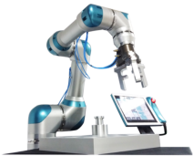  Fig. 1 7-DOF collaborative robot capable of collision detection and direct teaching | 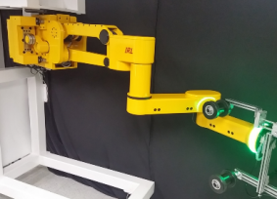  Fig. 2 6-DOF collaborative robot with passive gravity compensation

References
[1] H.-S. Kim, J.-K. Min, J.-B. Song, “Multi-DOF Counterbalance Robot Arm based on Slider-Crank Mechanism and Bevel Gear Units,” IEEE Trans. on Robotics, 32(1), pp. 230-235, 2016.
[2] R. Siciliano, L. Sciavicco, L. Villani, Robotics: Modeling, Planning and Control, Springer.

